# − Introduction to the biomass verification procedure−

## A. General context

The European Union policy – in accordance with international agreements such as the Kyoto Protocol – has set up renewable energy target of 20% by 2020 and stimulates biomass use in the power, heat and transport sectors. According to the European Renewable Energy Directives, European Governments encourage as well green power by granting support mechanisms under the form of green certificates or feed-in tariffs. This results in growing global demand for bio-energy resources originating from agriculture and forestry. But to effectively protect the environment a verification program with a quality mark is necessary in order to guarantee that fossil fuels are substituted in a sustainable fashion by biomass.

Therefore, on behalf of ENGIE Electrabel, ENGIE Laborelec and SGS have put in place a verification procedure applied to each biomass production unit. This procedure requires at least:

* the evaluation of the **energy consumptions** along the pellet supply chain (milling, drying, pelletising, transportation…). If the raw material is a residue (e.g. saw dust), the evaluation energy use within the supply chain starts only from the point where the residue is generated (e.g. sawmill);
* the **full traceability of the resources** that were used for manufacturing the biomass fuel and the evidence that those resources are **managed in a sustainable way**.



## B. Organisation

The present introductory document is **Doc 01**. The verification procedure relies on 4 key players delivering and checking 4 documents :

1. A **local independent inspection body** prepares an audit report based on a on-site visit and the procedure described in the **Pellet supplier audit procedure (Doc 03).** The auditor verifies the data delivered by the pellet supplier with respect to the origin of the raw material, the characteristics of the pellet product and the energy consumption related to production and local transport. The local independent inspection body is generally a local division of SGS or a local subcontracting party.
2. The **pellet producer** is requested to fill in a declaration about the information delivered to the auditor. This declaration is the **Pellet supplier declaration form (Doc 02).** If the audit report cannot be made immediately e.g. because the plant is not yet in operation, then a **Pre-audit declaration form (Doc 06)** can be filled in and verified by the auditor such that contracting issues can be organized in the meanwhile.
3. The **sea or fluvial transport company** is invited to deliver the long distance transportation data as described in the  **Pellet transport declaration form (Doc 04)**. The data are verified by SGS BELGIUM for coherency.
4. Finally, on the base of the audit report,**SGS Belgium** computes the balance of the energy use and the fossil carbon for the whole supply chain in the **Energy and Carbon Balance Form (Doc 05)**.

At the request of ENGIE/Electrabel, SGS Belgium and Laborelec have jointly designed this verification scheme for biomass pellets being fired in thermal power plants. The process owner of this process is ENGIE/Electrabel. ENGIE Energy Management is in charge of the daily application of the verification procedure. The coordinates of all players caring for the survey of the verification process of the pellet plants are mentioned hereafter.

### ENGIE ElectrabelFollow-up verification suppliers to ENGIE Electrabel

Avenue Bolivar 36, B-1000 Brussels, BELGIUM

Toon Bosmans

Tel.: +32 (0)2 519 36 92 Mob. +32 471 34 81 80  
e-mail : [toon.bosmans@engie.com](mailto:toon.bosmans@engie.com)

### ENGIELaborelec_gradientblueTechnical specifications and verification process: Laborelec

Rodestraat 125, B-1630 Linkebeek, BELGIUM

Dr.Ir. Yves Ryckmans

Tel. :+32 2 382 03 03 Mob.: +32 478 65 24 48

e-mail : [yves.ryckmans@engie.com](mailto:yves.ryckmans@engie.com)

### Inspection and independent reporting: SGS Belgium

Parc Créalys, rue Phocas Lejeune 4, B-5032 Gembloux, BELGIUM

Ir. François Ducarme

Mob. :+32 479-89.07.99 +44 778 71 48 792

e-mail: [francois.ducarme@sgs.com](mailto:francois.ducarme@sgs.com)

## C. Verification procedure

The verification procedure focuses on a traceable management system from the green power plant firing the biomass (by-)product back to the sustainable resource in the region of origin. The supply chain can be illustrated by the next scheme:

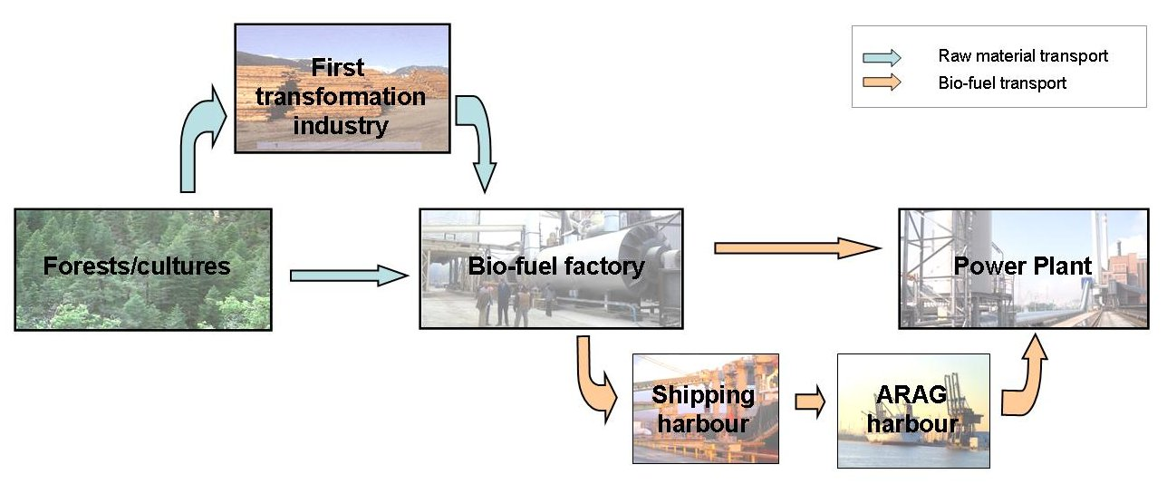

## Pellet Supplier Declaration Form (Doc 02)

This document is an official declaration that must be filled in by the manager of the producing company, and signed by him in the appropriate box. Normally the declaration is integrated into the next document Doc 03 but in the particular case the audit report cannot be made immediately, like in the case of a new pellet plant in construction phase, this document Doc 02 can be used in the meanwhile. The audit of the pellet plant must then be organized within the next 6 months.

## Pellet Supplier Audit Report (Doc 03).

1. An independent inspection company is appointed by SGS Belgium to perform an audit on site. The certified inspection company must send one of its auditors on site of the producer’s plant to check a set of parameters related to the pellets production (remote check is not allowed
2. The Doc 03 is meant to help the independent auditor to verify the data delivered by the operator of the pellet plant.It contains guidelines and checklists, in order to make sure that all required verification items are taken into account by the local auditor (wherever the inspection takes place). Once the document has been filled in by the local auditor, the last part is a declaration that must be signed by the operator of the pellet plant confirming that the data delivered to the auditor are correct and the quality of the end-product conform with the specifications.
3. The audit reportis endorsed by the local auditor (stamp/initials on each page and final signature).. Once the verification is completed, the local inspection company must send the audit report to SGS Belgium under electronic form.

## Pellet Transport Declaration Form (Doc 04)

This document is a declaration that might be filled in by the transport company in charge of the international transportation of the biomass from the country of origin to the thermal power plant. An official letter from the transport company might be delivered instead**.**

## Energy and Carbon Balance Form (Doc 05)

SGS Belgium approves the **audit report** (signature and stamp). Finally, SGS Belgium fills in the spreadsheet Doc 05 with the figures based on the above mentioned validated documents.